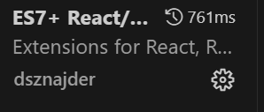

1. Create a folder Backend
2. 
3. 
4. Go into package.json file
5. 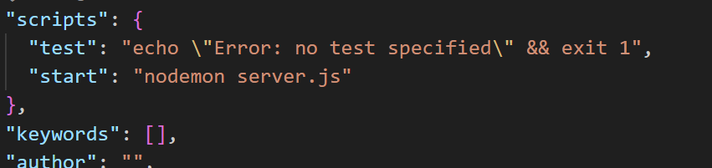
6. Now Create a server.json file
7. 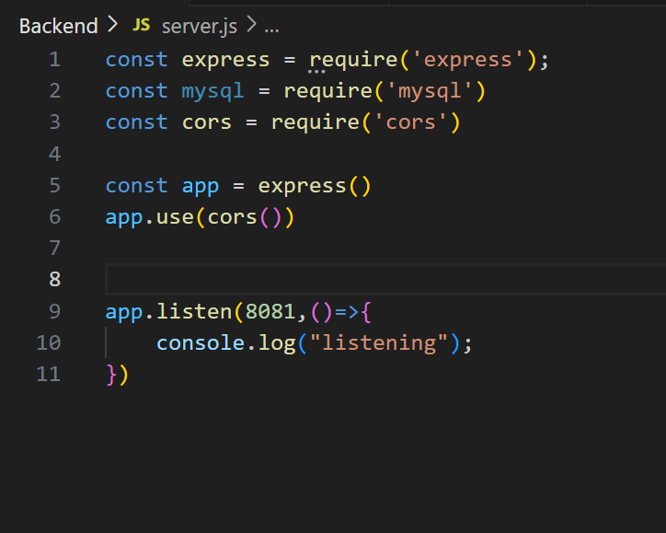
8. 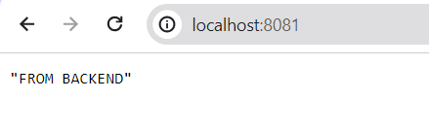
9. 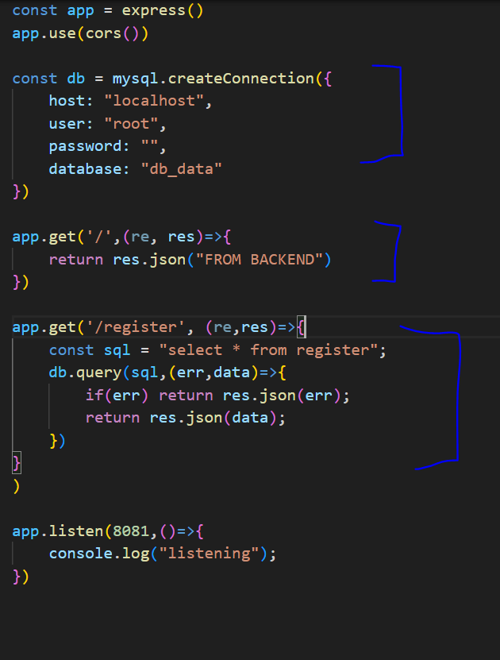
10. 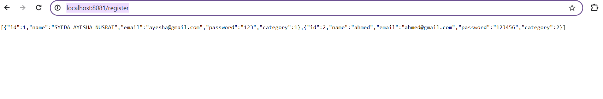
11. Now create a folder frontEnd
12. 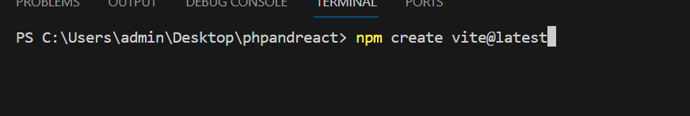
13. npm install
14. 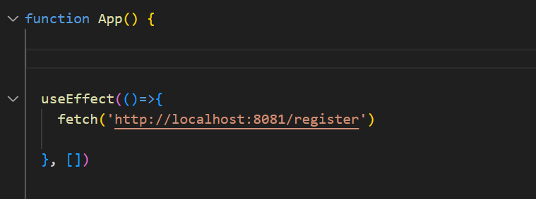
15. npm run dev
16. 